hhhhkhhl
PARISH OF ST THOMAS MORE
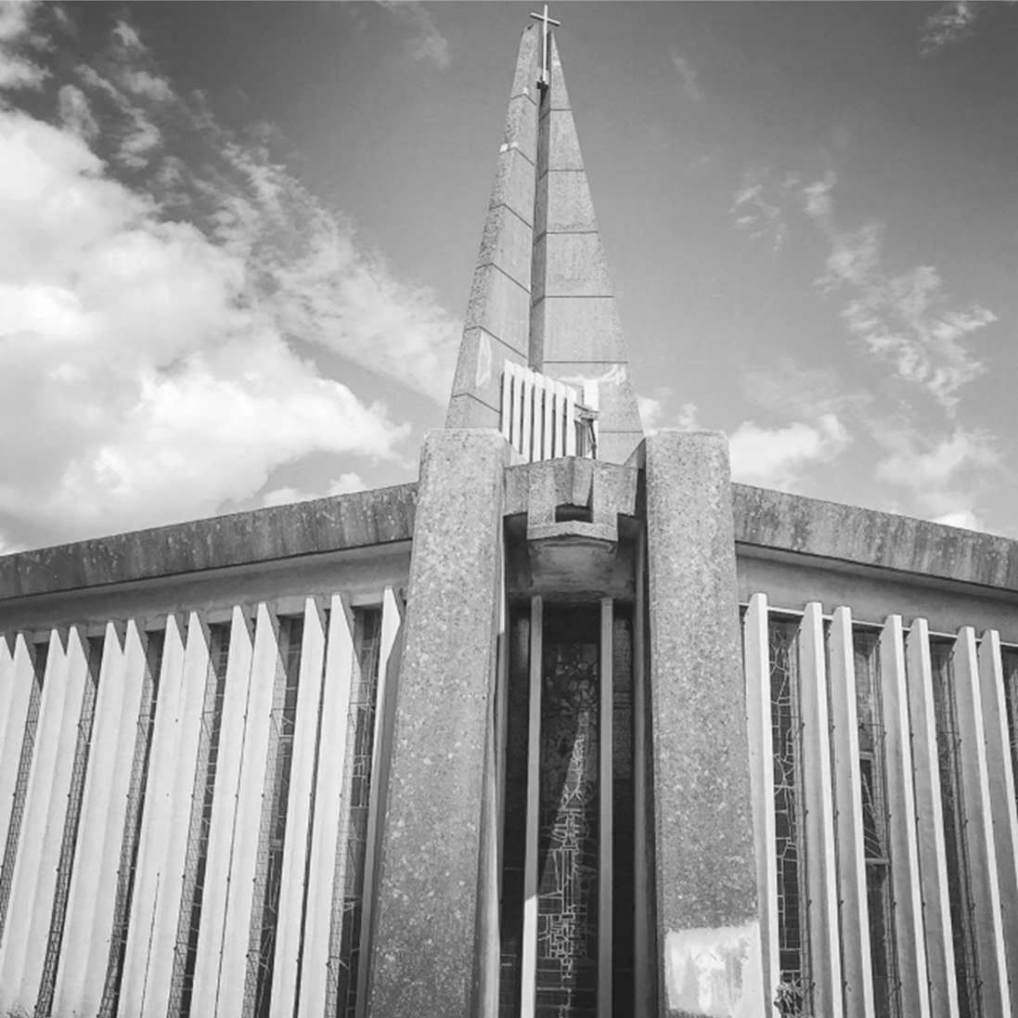

130 Horse Shoes Lane, Sheldon, B26 3HU ▪ Telephone 0121 743 2367

stthomasmore.bham@rcaob.org.uk
www.stthomasmorercchurch.com
▪
Parish Administrator
Maxine Winspear
Parish Priest
Fr Christopher Miller
Safeguarding
Sue Nightingale

The Parish is part of the Archdiocese of Birmingham: registered charity no. 234216

FIFTH SUNDAY OF LENT - Year B - 21st March 2021

Saturday 20th

Sunday 21st
 | 11:00am | Iris & Ian Salt, RIP Anniv.

Monday 22nd
Tuesday 23rd | 500pm6:00pm | Eucharistic Adoration  Derek McKenna, RIP.

Wednesday 24th
Thursday 25th Annunciation of the Lord | 5:00pm  6:00pm | Eucharistic Adoration  Pro Populo
Friday 26th | 9:30am | Jack Seery, RIP
 | 11:30am | Requiem Mass, Irene Quigley  Family only

Thank you for all your very kind assurances of prayer and so many get well soon cards. I am now starting to feel much better and I can hardly believe how ill I have been. However, I have been advised to be very careful and not to do too much. I pray God I will continue to get better and that Holy Week & Easter will all happen and we will have a joyful and holy celebration.
With my prayers for you all that you may stay safe and well.

Fr Christopher

pp

Holy Week & Easter
Palm Sunday - 28th March.
11:00am Holy Mass & Blessing of Palms
Maundy Thursday - 1st April.
7:00pm The Mass of the Lord’s Supper
Good Friday - 2nd April.
3:00pm The Celebration of the Lord’s Passion
Holy Saturday - 3rd April.
8:00pm The Easter Vigil & First Mass of the Resurrection
Easter Sunday - 4th April.
11:00am Solemn Mass of the Resurrection
Easter Day last for 8 days, you can come to any of the following Masses without tickets.
Monday 5th, Tuesday 6th & Friday 11th April at 11:00am.
Wednesday 7th & Thursday 8th April at 6:00pm.

ppp

The Church is open for prayer half an hour before each Liturgy.

Saturday 27th

Sunday 28th
 | 11:00am | Leo Kidd, RIP Anniv.

lk

TICKETS – Booking System is Now open On Line
- The Sacred Liturgies of Maundy Thursday, Good Friday and Holy Saturday together with all Sunday Masses will be by ticket only.
- Each Mass will require a separate booking.
- Please bring a printed copy of your ticket or have it available on your phone to show the entry steward on arrival.
- The maximum number of seats which can be booked online has been set at a capacity, so that we can still accommodate those elderly parishioners who may not have the facilities to book online.
- The booking system will close 1 hour before the start of each Mass. No one who turns up for Mass without a ticket will be turned away, unless the Church is at its capacity.

A Spiritual Holy Communion
My Jesus, I believe that You are present in the Most Holy Sacrament.
I love You above all things, and I desire to receive You into my soul.
Since I cannot at this moment receive You sacramentally, come at least spiritually into my heart.
I embrace You as if You were already there and unite myself wholly to You. Never permit me to be separated from You. Amen.

j
DAY OF REFLECTION
Tuesday 23rd March

The Government has asked for a day of reflection for Covid 19. Cardinal Nicols has also asked for us to make it a day of prayer and to visit the Blessed Sacrament.
There will be Eucharistic Adoration at 5:00pm followed by Holy Mass at 6:00pm.
It is a good time to pray for everybody’s well being for the future.

Recently Deceased –
Irene Quigley, Requiem Mass 11:30am, Friday 26th March.
Anne Brennan, Requiem Mass 11:00am, Wednesday 7th April.
Maureen O’Gorman, Requiem Mass 11:00am, Monday, 12th April.

May they rest in peace

Family members only to attend funeral Masses, Max 30 People.

The Celebration of the Paschal Triduum
This year the ceremonies are much reduced, however, thank God the Church will be open this year. Following guidelines form Rome the Bishops have sent carful information on how the Sacred Paschal Triduum is to be celebrated. On Maundy Thursday there will only be the Mass and no Gethsemane Watch. On Good Friday the Cross will be shown to the faithful for veneration with no individual coming to the Cross. The Easter Vigil will have many things not celebrated as usual but it still remains the most sacred of nights. We will still be able to enter into these most holy days we great devotion and love.

Holy Father’s Prayer Intentions
In the month of March, Pope Francis encourages us to pray an intention for evangelization, particularly with
regards to the sacrament of reconciliation. We pray that
we may experience the sacrament of reconciliation with renewed depth, to taste the infinite mercy of God.

CAFOD
We will have the usual second collection for Cafod on Palm Sunday.
Office Hours; The Parish Office is open between 10:30am and 2:30pm Mon, Tue & Wed. Any requests for Baptism Appointments, certificates, parish centre enquiries etc; should be made during these times. Tel. 0121 743 2367 or Email: stthomasmore.bham@rcaob.org.uk

Easter Offering Envelopes are available in the porch.

